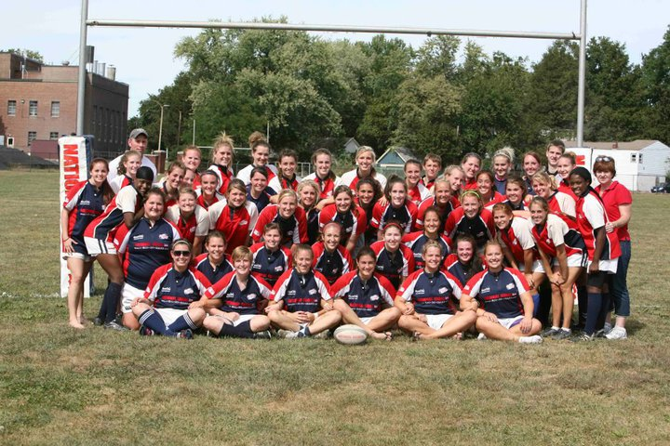

Dear friend of Shippensburg Rugby,
This year the Shippensburg University Women’s Rugby Club is in campaign for another Division II National Championship! This will be the fourth time in five years that the Lady Raiders will have a shot at the championship.
The spring 2012 season is going to be a long and hard road for us, but we are already off to a great start. We recently clinched the first place Eastern Pennsylvania championship against Temple University on November 13, 2011. This win advances us to the Mid-Atlantic regional playoffs, taking place the weekends of March 24th, and March 31-April 1. After this round, we will be put into the Sweet Sixteen round, which sends us to travel to Mobile, Alabama, or Columbus, Ohio. After the round of Sweet Sixteen’s, we are hopefully continuing on our journey to Stanford, California for the National Championship Finals in May, where we hope to obtain our Third National Championship title!
As you can imagine, travelling with 42 girls does get a little expensive. As a team, we have been working to raise money to cut down the cost on each player. But now, we need your help! We are looking for your support in our effort to win another National Championship, and would greatly appreciate any donations towards the SU Women’s Rugby Club. The donations will go towards traveling expenses and help our whole team experience the highest competition our sport has to offer. Please make checks payable to SU Women’s Rugby and send donations to
Katie Wallace
18 Kenneth Ave. Apt. 3
Shippensburg University
Shippensburg, PA 17257-2206

Or contact us at our website- www.shipwomensrugby.weebly.com

We would like to thank you in advance for your consideration and generosity. Your contribution to our team will help us reach or goal as National Champions!

Sincerely,
Shippensburg Women’s Rugby

